Name: World History B - TB
Rev. 3/20

Date:

Name and date are required! You will lose points if you leave them off!
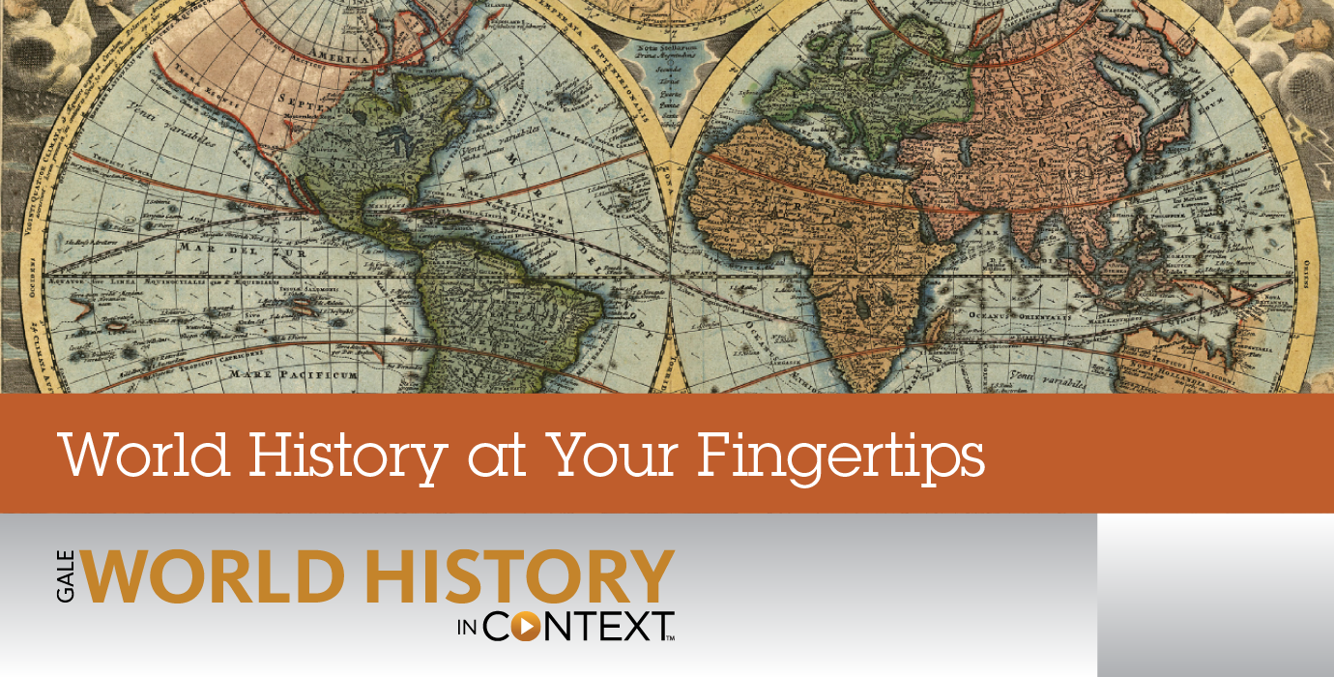
Unit 8 Section 1
Course overview: World History is a survey course covering from early civilizations to modern times, with emphasis on the political and philosophical roots of western democracy. Topics include: the rise of democratic governments; political, social and economic developments of the Middle Ages; the Renaissance and era of discovery; the growth of democracy and nationalism; the industrial revolution; and the two world wars. Postwar problems and recent developments are also studied.
CA State Standards:

10.4 Students analyze patterns of global change in the era of New Imperialism in at least two of the following regions or countries: Africa, Southeast Asia, China, India, Latin America, and the Philippines.
1.Describe the rise of industrial economies and their link to imperialism and colonialism (e.g., the role played by national security and strategic advantage; moral issues raised by the search for national hegemony, Social Darwinism, and 2.Discuss the locations of the colonial rule of such nations as England, France, Germany, Italy, Japan, the Netherlands, Russia, Spain, Portugal, and the United States.
3.Explain imperialism from the perspective of the colonizers and the colonized and the varied immediate and long-term responses by the people under colonial rule.
4.Describe the independence struggles of the colonized regions of the world, including the roles of leaders, such as Sun Yat-sen in China, and the roles of ideology and religion.

Assignments:

Chapter 25 Lesson 1: Colonial Rule in Southeast Asia
Worksheet: The Reach of Imperialism
Worksheet: "The March of the Flag and "Our Philippine Policy"
Chapter 25 Lesson 2: Empire Building in Africa
Worksheet: West African Countries
Chapter 25 Lesson 3: British Rule in India
Worksheet: Political Cartoon
Worksheet: Mohandas Gandhi
Chapter 25 Lesson 4: Imperialism in Latin America
Check-in 8.1

-Don’t Forget to start Key Assignment #8 due on 4/21-

Packet Directions
- These packets are assessed coursework.
- You will be scored based upon completion, effort, and accuracy.
- All short answer questions are to be completed IN YOUR OWN WORDS!
Unless a question specifically asks you to cite or quote from the text, answers copied word for word or cut and pasted from the online text (even with quotations) will be treated as copied and marked down. (See Inspire’s plagiarism policy in your course syllabus)
- When typing your responses please keep your answers in red font (when red font is provided)
- Packets are required to be uploaded as one whole unit and as one file (see the syllabus for details)
- Name and date are required! You will lose points if you leave them off!

-Content Vocabulary-
Directions: complete vocabulary words as you complete the unit, these may be copied from the text.
Imperialism | Refers to the extension of the nation’s power and influence by colonizing the citizens using the military force.
Indirect rule | Refers to one country controlling another country by establishing the indigenous power structures in that country.
Direct rule | Happens when the legislature, executive and civil administration of a country is taken control by imperial powers.
Annex | Refers to acquisition of the territory of a given state by another state through force.
Indigenous | Refers to the earliest inhabitants of the given area.
Sepoys | Refers to the Indian soldiers who are serving under the British orders
Viceroys | Refers to rulers who are exercising their authorities on behalf of a sovereign
Dollar diplomacy | Refers to the foreign policy that uses economic power instead of military force to further the agenda of a country in another country

-Chapter 25 Lesson 1: Colonial Rule in Southeast Asia-
Directions: Locate each heading below in your textbook. Then use the information under the correct heading and subheading to help you write each answer.

I. The New Imperialism
A. Why did nineteenth-century Europeans seek control of Asian and African societies?
Answer: ______both Asians and African societies had a lot of resources that were of interest to the European countries____

B. How was the “new imperialism” of the late nineteenth century different from earlier forms of imperialism?
Answer: ________ the new imperials unlike the earlier ones sought direct control of large territories
__

C. What role did racism play in imperialism?
Answer: __________ racism enhanced imperialism since people were tortured and persecuted because of their race

II. Colonial Takeover
A. Which Asian territories did Great Britain and France control during the nineteenth century?
Answer: __________ Great Britain took control of Singapore and Burma while France took over Vietnam, Cambodia and Annam as well as Annam
B. How did Thailand remain free from conquest during the nineteenth century?
Answer: __________ Together with his son, King Mongkut maintained promoted the western life while at the same time maintaining friendly relations.
III. Colonial Regimes
A. How did the Dutch apply indirect rule in the Dutch East Indies?
Answer: __________ The Dutch managed to establish a colony while retaining indigenous leaders who ruled locally

B. How did France apply both direct and indirect rule to Indochina?
Answer: __________ France is known to have imposed direct rule in southern Vietnam but ruled indirectly in Indonesia

C. a) What aspects of colonial rule were oppressive? b) What benefits did colonial rule bring to Southeast Asia?
Provide more than one example for each
c) Do you think the benefits outweighed the oppression that came with them? Explain your position.

Answer a): __________ colonial rule brough wars. For example, the opium war between Britain and china. Also, the trade wars resulted as every country wanted to dominate the other.

Answer b): __________ the colonial rule modernized some parts of asia especially China by introducing modern machinery. Also, Burma Singapore got modernized as a result of colonization.

Answer c): __________No, the benefits do not outweigh the oppression. This is so because many lives were lost as a result of the wars that resulted from the colonial rule.

IV. Resistance to Colonial Rule
A. How did the Burmese and Vietnamese people resist subjection?
Answer: __________ The Vietnamese government set the arm organization to defend itself.

B. a) What major conflict will colonial rule over Vietnam contribute to in the 1960s?
b) Explain how French colonialism and this conflict are connected.
Use page 648 to answer these questions.

Answer a): __________ colonial rule contributed to the violent ethnic conflicts across set of states

Answer b): __________France is connected because it contributed to the start of the Vietnam war by overthrowing the DRV government

Summary & Reflection

Directions: Using ideas from throughout the entire lesson, summarize the main ideas by answering the question below. Answers must be IN YOUR OWN WORDS. Point awarded based on accuracy and effort.

Use the wording of the definition of imperialism below to answer the questions that follow:

Imperialism: the policy or practice of extending power or dominion of a nation or territory by direct territorial acquisitions or by gaining indirect control over other areas of political or economic life. It includes exploitation of a weaker nation for the benefit of another nation and is against the will of those who are dominated.

Sample answer:
Britain in Burma: Britain “extended it’s power” over the nation of Burma by causing a collapse of the Burmese government and establishing control over the entire country. This was “direct territorial acquisition” of the “political and economic life” of Burma. They did this for their own “benefit” of protection of their colony in India. It was “against the will of” the Burmese as the monarch attempted to fight against Western domination.

France in Vietnam: Answer: __________On 23 September 1945, the French government with the help of British Commander in a place called Saigon in Vietnam organized and overthrew the democratic Republic Vietnamese Government. Since this move was against the people of Vietnamese people, Guerrilla warfare began.

The U.S. in the Philippines: Answer: __________The American colonization of Philippines took 48 years since starting at 1898 when Spain relinquished Philippines to the U.S until 1946 when Philippines got independence.

-Worksheet: The Reach of Imperialism-
The nineteenth century saw a new phase of Western expansion as European nations viewed Asian and African societies as a source for raw materials and a market for manufactured goods. By 1900, most of Southeast Asia and Africa were under the control of Western powers.

Imperialism did not begin in the 1800s, but it took a new form at that time. Earlier forms of imperialism by European powers involved overseas exploration and colonization from the sixteenth into the mid-eighteenth centuries. Europe then became involved in various nationalist revolutions and the Industrial Revolution, until about 1870, when new colonial endeavors took place in Asia and Africa. These undertakings were different from earlier ones, so they are usually defined as new imperialism.

How was new imperialism different from earlier forms? Many experts suggest that the main difference was largely economic; the European powers extended their government’s power, or their direct rule, to exploit their colonies’ cheap labor and natural resources. Other authorities point to noneconomic factors like nationalism, racism, and the pursuit of international power and prestige, which often motivated countries such as Germany and Belgium to rush to obtain as many colonies as possible. It seems clear that a combination of factors led to the new imperialism of the late nineteenth and early twentieth centuries.

In his 1902 book Imperialism, A Study, British liberal economist John Atkinson Hobson analyzed the reasons for new imperialism. He pointed out that income from industry was unevenly distributed, with wage earners not earning enough to buy the very products they produced. This led to large firms finding it necessary to open new markets abroad to sell their goods and invest their profits.

Applying Economics to History
1. Explaining: Why was there a shift to new imperialism in the late nineteenth-century?
Answer: __________ new emperors wanted to expand their territories because of economic, political and religious factors.

2. Analyzing: What was the economic advantage to direct rule over colonies?
Answer: __________ In a direct rule, it was only the aspects of governance that were taken control of by the foreigners while the natives took control of the subordinate duties which afforded them a unique economic advantage unlike in the colonial rule where all the aspects were taken care of by the colonizers.

3. Speculating: What do you think would have happened if workers in industrialized countries had been paid enough to purchase more of the goods they produced? Do you think the Western powers would have expanded into Asia and Africa anyway? Explain.
Answer: __________ Yes, Africa and Asia had a lot of resources that enticed the western countries.

-Worksheet: “The March of the Flag” and “Our Philippine Policy”-
Background: In the late 1800s, the imperialist forces of Europe began to actively carve out empires in Africa and Asia. The United States was beginning to formulate policies about occupation of foreign lands. The clash between the United States and Spain in the Spanish-American War led to the U.S. takeover of Spanish lands in the Philippines, Cuba, and Guam. The U.S. move to become an active player on the world stage was in part motivated by social Darwinism. The theory of social Darwinism suggested that certain groups were superior to others and therefore had a mission to spread Western ideas about religion and the economy. The desire to expand U.S. trade to Asia played a role in the creation of a U.S. empire. Senator Albert Beveridge from Indiana clearly stated the ambitions of the United States in campaign speeches and speeches before the Senate. The U.S. policy of claiming territory in the Philippines went directly against the wishes of the Filipino people even though they fought alongside the Americans against the Spanish in the war.

Directions: The following selections are from speeches made by Albert Beveridge. Read the selections. Then answer the questions.

Shall the American people continue their march toward the commercial supremacy of the world? . . . Have we no mission to perform, no duty to discharge to our fellow-man? Has God endowed us with gifts beyond our deserts and marked us as the people of His peculiar favor, merely to rot in our own selfishness. . . . The riches of the Philippines have hardly been touched by the finger-tips of modern methods. And they produce what we consume, and consume what we produce—the very predestination of reciprocity—a reciprocity "not made with hands, eternal in the heavens." They sell hemp, sugar, cocoanuts, fruits of the tropics, timber of price like mahogany; they buy flour, clothing, tools, implements, machinery and all that we can raise and make. Their trade will be ours in time.
—Albert Beveridge, from “The March of the Flag” speech, 1898

They are not yet capable of self-government. How could they be? . . . They know nothing of practical government except as they have witnessed the weak, corrupt, cruel and capricious rule of Spain. What magic will anyone employ to dissolve in their minds and characters those impressions of governors and governed which three centuries of misrule has created? What alchemy will change the . . . quality of their blood and set the self-governing currents of the American pouring through their Malay veins? How shall they, in the twinkling of an eye, be exalted to the heights of self-governing peoples which required a thousand years for us to reach, Anglo-Saxon though we are?
—Albert Beveridge, first session of 56th Congress, Jan. 9, 1900

Questions for Worksheet: “The March of the Flag” and “Our Philippine Policy”
1. Identifying Perspective: Which phrases illustrate Beveridge’s belief in social Darwinism?
Answer: __________ “Shall the American people continue their march toward the commercial supremacy of the world?” and “They are not yet capable of self-government. How could they be?”

2. Identifying Central Issues: How did Beveridge view the United States’ role in controlling the Philippines?
Answer: __________ Beveridge viewed America imposed itself to control the Philippines even when the Philippines believed they are capable of self-governance.

3. Compare and Contrast:
a) How did Beveridge compare the people of the United States with the people of the Philippines?
b) How do you know?
Answer a): __________ Beveridge believed that the Philippines were capable of self-governance unlike Americans who have always ruled the vulnerable and the weak communities

Answer b): __________ I know that the American is the most powerful and democratic country

4. Determining Cause and Effect
What ideas in Beveridge’s speeches suggest a justification for the United States taking control of the Philippine government?
Answer: __________ one of the ideas suggested by Beveridge is that Philippines is a developing country that still needs support of other countries.
5. Drawing Conclusions
What would Beveridge’s position likely be with regard to trade in East Asia?
Answer: __________ Beveridge will not support the trade in East Asia because it will only benefit the Asian people and not the Philippines.
6. Predicting Consequences
How will the takeover of the Philippine government by the United States influence attitudes and actions of the Filipino people?
Answer: __________ the Filipino people will feel weak and vulnerable for being ruled on their own land

-Chapter 25 Lesson 2: Empire Building in Africa-
Directions: Read the lesson and complete the outline below. Refer to your textbook to fill in the blanks.

I. West Africa and North Africa
A. ____________Great britain______ annexed the west coastal states and established a protectorate in __________Nigeria________. France added French __________west africa________ to its empire.

B. Egypt lost control over the _______Suez Canal___________ and became a ____British protectorate______________
C. Italy failed to conquer ______Ethiopia____________ but successfully seized Tripoli, renaming it _____________Libya_____ .

II. Central and East Africa
A. Explorer Henry ________Stanley__________ and missionary David _____Livinstone_____________ explored and mapped the interior of ____Africa______________.

B. The Belgian king ________Leopold __________ was the driving force behind the domination and exploitation of the _________________Congo_ .

C. European countries met at the ______Berlin conference____________ to settle claims for territory in Africa. No African _____________countries_____ were present at this conference.

III. South Africa
A. The _______boers___________ were descendants of the original _______Dutch___________ settlers and dominated some areas of South Africa.

B. The indigenous _______Zulu___________ people mounted a successful resistance against the ________________Boers__

C. Cecil _____________Rhodes_____ sought to establish British colonies from “the _____Cape_____________ to Cairo.”

D. During the Boer War the British forced _____African_____________ women and children into ____________concentration______ ___camps____________ where lack of food caused ___________disease and _______ _____________malnutrition_____.

E. After the British won the ______Boer war____________ , they renamed the Cape Colony and the _boer republicans____________ republics the ___Union of south Africa_______________ .

IV. Effects of Imperialism
A. By 1914, _____________Liberia_____ and ____Ethiopia______________ were the only two independent African nations.

B. _____________Indirect_____ rule by the British maintained tribal customs. direct__________________ rule by the French stressed _____________assimilation_____ and offered limited legislative opportunities.

C. African nationalists and intellectuals were often educated in ____colonial______________ schools or in ______________western____ nations.

D. The African intellectuals recognized the gap between theory and practice in colonial policy. Westerns had exalted _________________, ___religious______________, and political _______factors__________ but did not apply these values to ____________rule_____.

E. To many Africans colonialism meant losing their _____lives____________, or doing hard labor in European owned __________countries_______ and ___________states______.

F. Europeans expressed their _________love________over Africans in other ways too. _____most of the____________ clubs, schools, and churches were set up in the European colonies.

Summary & Reflection

Directions: Using ideas from throughout the entire lesson, summarize the main ideas by answering the question below. Answers must be IN YOUR OWN WORDS. DO NOT RESEARCH ANSWERS ONLINE! Points awarded based on accuracy and effort.

Using the information on page 504, under the subheading, “Rise of African Nationalism” explain why conquered African peoples will eventually revolt against their foreign occupiers. Cite several examples from your textbook.
Answer: __________ Africans revolted because their rights were violated. For example, Africans were not allowed to speak in public places. Also, Africans lost their property especially land which was taken away.

-Worksheet: West African Countries-
Background
Born in Sierra Leone in 1835, James Africanus Beale Horton was the son of freed slaves. Educated in Freetown and in the United Kingdom, he became a medical officer in the British army, where he faced prejudice and poor treatment from other officers. When Horton returned to Africa, he was assigned to the Gold Coast (later to become Ghana). During this time, Horton developed his ideas for African self-government, partially in response to the widespread racism of the time. Horton worked tirelessly on behalf of the cause of African independence. However, his efforts to convince the British authorities to adopt measures and work with Africans were unsuccessful, and he received recognition for his contributions only several decades after his death.

Joseph Ephraim Casely Hayford was born in the Gold Coast in 1866. Like Horton, Casey Hayford studied in England. After earning a law degree, he returned to the Gold Coast to help a coalition of African leaders fight the colonial government’s efforts to seize and regulate African lands. He was also involved with the formation of the Congress of British West Africa, a group of educated black leaders who were dedicated to the cause of African independence in British-occupied West Africa. In his published works, Casely Hayford articulated his belief that Africans should preserve their own cultures and work for independence under enlightened black leadership. He also expressed his contempt for the hypocrisy of British policies and attitudes that thwarted these efforts.

Directions: Read the following selections. Then answer the questions.

Bearing in mind the foregoing, it will be my province to prove the capability of the African for possessing a real political Government and national independence; and that a more stable and efficient Government might yet be formed in Western Africa, under the supervision of a civilized nation, in conformity with the present Resolution of the Committee of the House of Commons . . . By nature the African is a social being, possessing the capacity of commanding and obeying, and that type of improvement which advances as the reason is cultivated, which are the essential elements both of a political government and a political community. . . .
—James Africanus Beale Horton, West African Countries and Peoples, 1865

[I]t is simply the primitive instinct of acquisitiveness in man which operates in the case of nations, no matter the extent of their boasted civilisation. Primitive man in primitive society says: “I will take your land, or your hut, if you will give it to me. If not, I will take it. When I have taken it, and you cannot retake it, of course, I will keep it.” The civilized nations of the world are to-day like unto primitive man, else international courts of arbitration would more frequently be sitting in one European capital or another, and the weak nations of the earth would have little peace, if not little justice.
—Joseph Ephram Casely Hayford, Gold Coast Native Institutions, 1903

Questions for Worksheet: West African Countries
1. Analyzing Primary Sources: Under what conditions did James Africanus Beale Horton believe that Africans could be capable of forming an independent national government?
Answer: __________ Yes, James believed that africans are naturally social being that possess a commanding and obeying capacity for self-control

2. Making Inferences
a) To whom was Horton referring in the phrase “under the supervision of a civilized nation”?
b) What role do you think he envisioned for this nation to play?
Answer a): __________developed countries like the United States

Answer b): __________ supervisory role

3. Comparing
a) What observation about primitive man in primitive society did Joseph Ephraim Casely Hayford make?
b) In what way does he compare primitive man to civilized nations?
Answer a): __________primitive men want to take other people’s property by force

Answer b): __________ America and other civilized countries took the property of Africans by force

4. Identifying Central Issues
Why did Casely Hayford believe that the weak nations of the earth would have little peace and perhaps little justice?
Answer: __________ because they don’t have power to defend themselves unlike civilized nations

5. Drawing Conclusions: Why did Casely Hayford resent the British presence in and control of West African countries?
Answer: __________ because they were taking all the natural resources

6. Making Generalizations
Explain why Horton, Casely Hayford, and other educated black leaders of the late nineteenth and early twentieth centuries are important figures in the African struggle for independence.
Answer: __________ all of them create awareness that black people are not less-human. They have the power to do anything like the white who colonized them

-Chapter 25 Lesson 3: British Rule in India-
Directions: Read the lesson and complete the outline below. Refer to your textbook to fill in the blanks.

I. The Great Rebellion
A. _____________Sepoyos_____ were Indian soldiers who served under British officers and were hired by the ___________British east India company_______ , which had been granted power to become actively involved in Indian political and military affairs.

B. The Sepoy Mutiny, or _________the first war of independece_________ as it is called in India, failed due to a lack of organization and rivalries between __________Hindus________ and _____Muslims_____________ .

C. The failed rebellion helped fuel Indian _________Nationalism_________ and prompted the British Parliament to transfer powers from the East India Company directly to the _________________British Government_ .

II. British Colonial Rule
A. In their efforts to bring order and stability to India, the British implemented a new school system, built _____________roads_____ and a _____rail_____________ network, and introduced a new _____postal_____________ service. The new system served only _____small percentage_____________ Indians, however. ________growth rate__________ of the Indian population remained __fixed________________.

B. British rule brought ___________unemployment_______ to millions of Indians. Economic costs of British rule in India were great and included the destruction of local __industries________________ , such as the Indian __________textile________ industry, which put thousands of women out of work.

C. The British sent ____________the military______ to collect taxes. They thought that using ______local tax collectors_________ officials would make it easier to collect taxes but instead these local tax collectors abused their positions and ___________ate_______ taxes and when the Indian peasants couldn’t pay they took their __________property________.

D. To fuel the British textile industry, the British compelled many Indian farmers to switch from growing food to growing ______cotton____________. As a result, there were food shortages. Between 1800 – 1900 _____________many_____ Indians died of __________hunger________ as a direct result of British imperialism in India.

E. British _______racial___________ attitudes cut deeply into the pride of many Indians and led to the rise of Indian _____________nationalist_____ movements.

III. Indian Nationalists
A. At first many Indian nationalists preferred __________reconcilaition________ to revolution, but the slow pace of reform convinced many that relying on British goodwill was _______dangerous___________. The _____nationalist movement_____________ , formed in 1885, pushed for a share in the governing of India but faced internal difficulties due to differences between Hindus and Muslims.

B. ____________Gandhi______ began a nationalist movement in India based on __nonviolent________________ resistance, which ultimately led to Indian independence.

IV. Colonial Indian Culture
A. In response to British disdain for ________indians__________ culture, a cultural awakening in India emerged which led to the search for a new national identity and a modern form of ___literary_______________ expression.
B. The life mission of Rabindranath _____________Tagore_____ , a _________writer_________ and ________poet__________ as well as many other things, was to promote pride in the face of British domination.

Summary & Reflection

Directions: Using ideas from throughout the entire lesson, summarize the main ideas by answering the question below. Answers must be IN YOUR OWN WORDS. DO NOT RESEARCH ANSWERS ONLINE! Points awarded based on accuracy and effort.

Explain how the Indian National Congress, Mohandas Gandhi, and Rabindranath Tagore all contributed to eventual independence from British rule. Be specific for each in your response.

Answer: __________ Gandhi started a movement aimed to peaceful fight for the rights of all Indians. On the other hand, Tagore used authored books that empowered the Indians by making them understand that they have the power to rule themselves.

-Worksheet: Political Cartoon-
Two techniques political cartoonists often use to express their points of view about their subjects are symbolism and metaphor. Symbolism is the use of one thing—such as an object, animal, or image—to stand for something else. For example, a white dove with an olive branch is often used as a symbol of peace. A metaphor, such as “She is a dove,” is a direct comparison, linking the qualities of one thing to another to show ways in which they are similar.

Directions: The political cartoon conveys a particular point of view about British “new imperialism” in the late nineteenth century. Look closely at the cartoon, analyze it, and answer the questions that follow
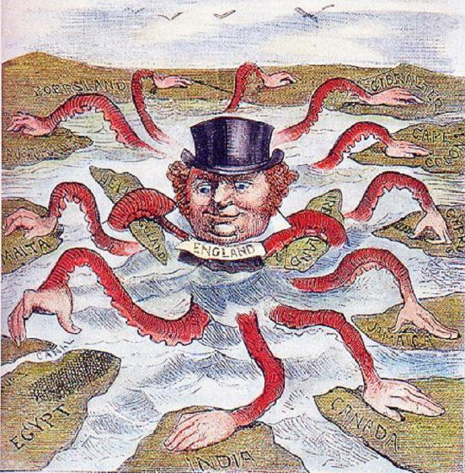
Background: In the late 1800s, England, Germany, France, Belgium, and other powerful European nations—motivated primarily by a desire for raw materials and new markets in which to sell manufactured goods—embarked on an ambitious quest to control overseas territories on every continent. This “new imperialism” marked an unprecedented wave of economic expansion. From the 1870s until the end of World War I, European imperialist nations established up to three times more overseas territories than they had in the preceding 75 years. Heated rivalries existed, and the quest for more territories was often for strategic as well as for economic advantage. For example, Egypt was desirable because it served as a natural connecting point for trade routes running between Europe, Asia, and Africa. Caption: “The Devilfish in Egyptian Waters,” unknown American artist, 1882.
Egypt became even more strategically crucial to Europe after the Suez Canal was built in 1869. The canal, which had been largely funded by France and England, linked the Red Sea to the Mediterranean Sea. Whoever controlled the canal would have enormous control over trade and the strategic ability to prevent the passage of enemy ships during times of war. In 1882, taking advantage of a French withdrawal, England took over Egypt unofficially, without formal or internationally recognized political control. Britain kept a military presence in Egypt and interfered in Egyptian political affairs, but Egypt’s status remained undefined until the British claimed it as a protectorate in 1914.

“The Devilfish in Egyptian Waters” depicts a human-headed octopus with hands reaching for Egypt while touching other territories already held by Britain. The cartoon was published in 1882, the year the British began to take control of Egypt. The octopus has the head of John Bull, a portly and affluent figure invented in the eighteenth century to satirize political events. By the nineteenth century, the familiar and reassuring figure of John Bull had become a popular caricature and the recognized symbol of England.

Questions for: Worksheet - Political Cartoon
1. Describing
Do your best to describe the details you see in this cartoon. What are some of the unusual characteristics and behaviors of this octopus? What does the octopus represent? What is the octopus grabbing at?

Answer: __________ the octopus is grabbing all the territories and, in the process, displacing other innocent animals who lived peacefully in their territories. The octopus represents the civilized countries which have colonized the developing countries.

2. Inferring
What point of view is the cartoonist expressing about British imperialism?

Answer: __________ gluttonous

3. Explaining
In Empire and Commerce in Africa: A Study in Economic Imperialism— published in 1919—British writer, publisher, and anti-imperialist Leonard Woolf (1880–1969) noted, “The part played by Europe in the world during the last hundred years has been that of a political octopus. States have stretched out from Europe the tentacles of their political power and organization, and have grasped or enmeshed practically the whole of Asia, Africa, and Australia, together with all the islands of all the oceans.” Explain why the metaphor of an octopus is appropriate in describing an imperialist power like nineteenth-century England.

Answer: __________ octopus is appropriate because it gives a clear picture of how the western countries have taken control of African countries leaving nothing for the natives

4. Synthesizing
The image of an octopus has often been used in political messages and propaganda to represent the greedy or power-grabbing ways of various nations, political groups, or institutions. Think of another metaphor that would be an appropriate and meaningful representation of an imperialist nation (for example: an imperialist nation is like a/an _______, because…). Explain your choice.

Answer: __________ hyena is another metaphor that fits the western nations. Hyena is selfish and that is why it eats everything without thinking of other animals.

-Worksheet: Mohandas Ghandhi-
Mohandas Gandhi (1869–1948)

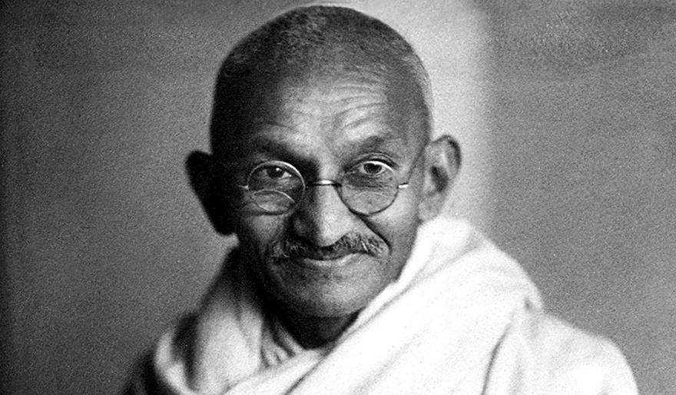
Mohandas K. “Mahatma” Gandhi was born in Porbandar, in Western India. He studied law in England, then worked in South Africa for an Indian law firm. There Gandhi organized the Indian community to protest racism and unjust laws, exposing the discrimination Indians experienced in the British colony.

Gandhi returned to India in 1915 and became active in the movement for Indian independence
from British rule. As a leader in the Indian About the Image: This photograph of Mohandas Gandhi was taken on Nov. 1, 1942.
National Congress, Gandhi directed various nonviolent campaigns. Gandhi’s nonviolent approach to confronting injustice and producing change transformed British India. It also inspired future leaders, such as Martin Luther King, Jr., in the United States. Gandhi’s ultimate political goal of Indian independence was realized in 1947. Less than six months later, a religious fanatic assassinated Gandhi in Delhi.

Using the text above
1. While in British controlled South Africa, what issues did Gandhi protest?
Answer: __________ the racial discrimination of Indians living in south Africa

2. Given what he did in South Africa, why do you think he became active in the movement for Indian independence
once he returned home to India in 1915?

Answer: __________ Gandhi knew that Indians were being oppressed by their colonizers and it was necessary for Indians to rule themselves

3. Gandhi’s non-violent approach to fighting injustice was influential on which American leader?

Answer: __________Martin Luther King Junior

4. Analyzing Information: In 1930, to protest the British government's salt tax, Gandhi led thousands of Indians on a 200-mile march to retrieve salt from the sea. How does this example illustrate nonviolent protest?
Answer: __________ because no people were killed or property destroyed in the process of this march

-Chapter 25 Lesson 4: Imperialism in Latin America-
Directions: Locate each heading below in your textbook. Then use the information under the correct heading and subheading to help you write each answer.

I. The U.S. in Latin America
A. How and when did the United States begin to extend its influence in Latin America?
Answer: __________ by involving itself in the Spanish-American War in 1800s

B. a) Use the glossary to define “protectorate”. b) How did the U.S. make Cuba a “protectorate in 1898?
c) What other foreign territory did the U.S. acquire as a result of our war with Spain?

Answer a): __________those states that are controlled by other states

Answer b): __________ by defending Cubans against other foreign powers

Answer c): __________Philippines

C. a) Explain how the U.S. helped create the nation of Panama.
b) What economic interest did the U.S. have that prompted it to interfere with the nation of Columbia?

Answer a): __________ the U.S signed Hay-Herran Treaty in 1903 with Colombia. This granted the U.S the powers to use Panama in exchange for financial compensation.

Answer b): __________ the FARC assets were of interest to the U.S

D. What was the Roosevelt Corollary?
Answer: __________ it’s a statement that stipulates how the U.S will be intervening to ensure that other nations in the Western Hemisphere fulfilled their objectives.

E. What is dollar diplomacy?
Answer: __________ Refers to the foreign policy that uses economic power instead of military force to further the agenda of a country in another country

F. Opinion: How can dollar diplomacy be an effective way to control other nations? (Hint: Think about your own life
experiences, has anyone ever had control over your freedom because they control the money in your life?)

Answer: __________ by giving other nations the financial source, those nations will accept to be controlled.

G. List all the nations the U.S. sent the military to during this time period.
Answer: __________Venezuela and Cuba

H. How long did U.S. troops occupy Haiti and Nicaragua?
Answer: __________19years

II. Revolution in Mexico
A. Why were the majority of Mexicans unhappy with Porfirio Díaz’s leadership of Mexico?
Answer: __________Porfirio Misconducted himself

B. What role did Pancho Villa and Emiliano Zapata play in the Mexican Revolution?
(Hint: see the picture caption on page 512)

Answer: __________Emiliano Zapata formed and commanded the Liberation Army while Pancho Villa advocated for the poor and land reform

C. Opinion: Why might some people view Pancho Villa and Emiliano Zapata as a type of “George Washington”?

Answer: __________because they put the interest of other people before their own interest

D. How did the Mexican Constitution of 1917 help workers in Mexico? (List the three provided)
Answer: __________workers gained their rights, workers gained their citizenship and lastly, it allowed for government to be formed.

E. What were the main effects of the Mexican Revolution?
Answer: __________it led to the formation of 1917 constitution.

III. Prosperity and Social Change
A. As more investment came into Latin America what kinds of raw materials were being shipped (exported) out?
Answer: __________agricultural products and natural resources like iron

B. Despite some economic growth, what were some of the social problems Latin American nations still faced?
Answer: __________environmental changes

Summary & Reflection

Directions: Using ideas from throughout the entire lesson, summarize the main ideas by answering the question below. Answers must be IN YOUR OWN WORDS. DO NOT RESEARCH ANSWERS ONLINE. Points awarded based on accuracy and effort.

Imperialism: the policy or practice of extending power or dominion of a nation or territory by direct territorial acquisitions or by gaining indirect control over other areas of political or economic life. It includes exploitation of a weaker nation for the benefit of another nation and is against the will of those who are dominated.

Using the provided definition of imperialism (above) and the examples on U.S. imperialism from ch.25 lsn.4, explain how the Roosevelt Corollary is imperialistic and explain how dollar diplomacy is imperialistic.
Answer for the Roosevelt Corollary: __________ he wanted the U.S to intervene in helping countries achieve their objective even if they are not invited. This is against the will of the weaker nations and it will constitute imperialism

Answer for the dollar diplomacy: __________ dollar diplomacy seeks to exploit the economic misery of the developing countries which is morally wrong hence, it therefore constitutes to imperialism.

-STOP!- Do not move on to Unit 8 Section 2 until you have completed the Check-in 8.1.
-STOP!- Key Assignment is due prior to taking the Unit Test and before moving to the next Unit.

